Name:

Assignment 2

Part I. (15 pts) One-sample t-test
A cookie manufacturer claims that the average weight of a package is 16.2 oz. You purchase a box containing 25 packages and weigh each one. The sample has a mean of 15.9 oz and a standard deviation of 0.45 oz. Suspicious of the claim; you hypothesize that the true mean weight is lower than 16.2 oz.
How would you test your hypothesis? Answer the following questions.

- State the null and alternative hypotheses in words (2.5 pts).

Null hypothesis: The true mean weight of the cookie package is 16.2 oz.

Alternative hypothesis: The true mean weight of the cookie package is less than 16.2 oz.

- State the null and alternative hypotheses in symbols (2.5 pts).

H₀: $μ=16.2$
H_{A}: $μ<16.2$

- Perform a one-sample t test at the α=0.01 significance level. Show your calculations. What is your conclusion? Is the manufacturer’s claim supported, or is there evidence that average package weight is significantly less than 16.2 oz? Explain your reasoning (10 pts).

$$t=\frac{x-μ}{σ/\sqrt{n}}=\frac{15.9-16.2}{0.45/\sqrt{25}}=-3.33$$

$$P\left(t<-3.33\right)=0.00139$$

With p < 0.01, we reject the null hypothesis. There is sufficient evidence to suggest that the true mean weight of the cookie package is less than 16.2 oz.

Part II. (15 pt) One-sample t-test – ECLS HEIGHT
For this part, you will use the ECLS-K dataset (https://nces.ed.gov/ecls/). Refer to the codebook provided in the first assignment and the corresponding tutorial for detailed information about the dataset, its variables, and the process for recoding missing values before conducting the analyses below.
Your friend claims that the average height of children starting kindergarten in the U.S. is less than 45 inches. Assuming that the ECLS-K sample dataset is representative of this population, you will test your friend’s hypothesis.
Data preparation:
                - Import the ecls-k-sub.csv dataset into R.
                - According to the codebook, the variable X1HEIGHT is a numeric variable that records children’s composite height (in inches). The values -9, -8, and -7 represent missing data.
                - Recode these missing values to NA for accurate analysis.
Once you prepare your data for analysis, you can answer the following questions:

- State the null and alternative hypotheses in words (2.5 pts).
Null hypothesis: The true mean height of U.S. kids starting kindergarten is 45 inches.
Alternative hypothesis: The true mean height of U.S. kids starting kindergarten is not 45 inches.
- State the null and alternative hypotheses in symbols (2.5 pts).
H₀: $μ=45$
H_{A}: $μ<45$
- Run a one-sample t-test to test your friend’s claim. Copy/Paste the R output below (2pts).

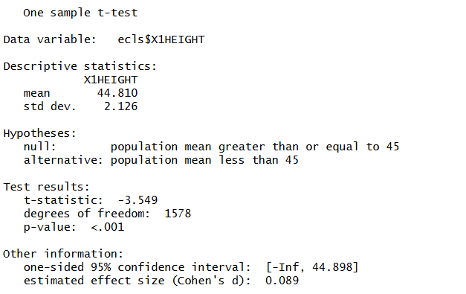

- Fill in the blanks in the following summary write-up according to your analysis results. Round the numbers to the second decimal when reporting (8 pts).

The average height for 1579 children in this particular sample was 44.81 with a standard deviation of 2.13. A one-sample t-test was conducted to test whether the average height in the population was equal to 45 inches. Based on the results of a one-sample t-test, we reject the null hypothesis that the average height in the population is equal to 45 inches, t (1578) = -3.55, p < 0.01, Cohen’s d = 0.09.

Part III (15 pts). Understanding the data structure for an independent samples t-test
Red 40, a monoazoaryl disodium disulfonate, has been approved in the U.S. since 1971 as a color additive in foods and drugs. To evaluate the safety of Red 40, researchers conducted a feeding experiment using mice. The mice were randomly assigned to either a control group or an experimental group. Mice in the control group were not exposed to Red 40, while mice in the experimental group were exposed to a fixed amount of Red 40 each week. The researchers recorded each mouse’s lifespan (in weeks), as shown below:
Time of Death (in weeks)
Control Group | Experimental Group
70 | 34
77 | 36
83 | 48
87 | 48
92 | 65
93 | 91
100 | 98
102 | 102
102
103
96

Suppose we want to perform an independent samples t-test to compare the mean lifespan of mice in the control and experimental groups. First, create the dataset in R using the code below. The time variable contains all lifespans (in weeks) for both groups. The first 11 values correspond to the control group, and the last 8 correspond to the experimental group.

time <- c(70, 77, 83, 87, 92, 93, 100, 102, 102, 103, 96,
34, 36, 48, 48, 65, 91, 98, 102)

Next, create a variable to label each observation as belonging to either the control or experimental group:

category <- c(rep(“control”, 11),
rep(“experiment”, 8))

Then combine the two variables into a single data frame:

death_df <- data.frame(time, category)

Convert the category variable into a factor so that R can use it correctly in the analysis:
death_df$category <- as.factor(death_df$category)

You can examine the structure of the new data frame object and view it by running:
str(death_df)

View(death_df)

Using the independentSamplesTTest function from the lsr package, run an independent samples t-test to test the hypothesis that the average lifespan is different between two groups, and paste a screenshot of your R output below.

independentSamplesTTest(formula = time ~ category,
data = death_df,
var.equal = TRUE,
one.sided = "control")
##
## Student's independent samples t-test
##
## Outcome variable: time
## Grouping variable: category
##
## Descriptive statistics:
## control experiment
## mean 91.364 65.250
## std dev. 11.012 28.065
##
## Hypotheses:
## null: population means are equal, or smaller for group 'control'
## alternative: population mean is larger for group 'control'
##
## Test results:
## t-statistic: 2.825
## degrees of freedom: 17
## p-value: 0.006
##
## Other information:
## one-sided 95% confidence interval: [10.035, Inf]
## estimated effect size (Cohen's d): 1.313
Not assuming equal variances:
independentSamplesTTest(formula = time ~ category,
data = death_df,
var.equal = FALSE,
one.sided = "control")
##
## Welch's independent samples t-test
##
## Outcome variable: time
## Grouping variable: category
##
## Descriptive statistics:
## control experiment
## mean 91.364 65.250
## std dev. 11.012 28.065
##
## Hypotheses:
## null: population means are equal, or smaller for group 'control'
## alternative: population mean is larger for group 'control'
##
## Test results:
## t-statistic: 2.496
## degrees of freedom: 8.58
## p-value: 0.018
##
## Other information:
## one-sided 95% confidence interval: [6.826, Inf]
## estimated effect size (Cohen's d): 1.225

Part IV (15 pts). Understanding the data structure for a dependent samples t-test
A researcher is studying how noise influences a person’s ability to solve statistical problems. Ten students are randomly selected and each student experiences both conditions: a noisy environment and a quiet environment. Each condition lasts 10 minutes. During that time, students solve a set of statistical problems, and the researcher records the number of mistakes each student makes in each condition. The goal is to determine whether there is a significant difference in the average number of mistakes made under the silent and noisy conditions.
The table below shows the number of mistakes made by each of the 10 students. The first value in each row corresponds to the same student across both conditions.

Silent | 6 | 7 | 7 | 5 | 4 | 4 | 6 | 9 | 5 | 7
Noisy | 9 | 9 | 6 | 7 | 6 | 7 | 9 | 11 | 7 | 9

To analyze this data, we’ll create a dataset in R as follows:
silent <- c(6, 7, 7, 5, 4, 4, 6, 9, 5, 7)
noisy <- c(9, 9, 6, 7, 6, 7, 9, 11, 7, 9)
mistakes_df <- data.frame(silent, noisy)

View(mistakes_df)

Using the oneSampleTTest function from the lsr package, run a dependent samples t-test (also called a paired-samples t-test) to compare the mean number of mistakes in the silent and noisy conditions.
Paste a screenshot of your R output below.

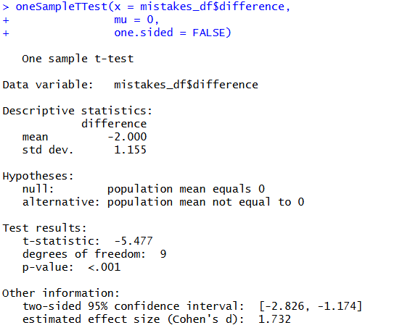

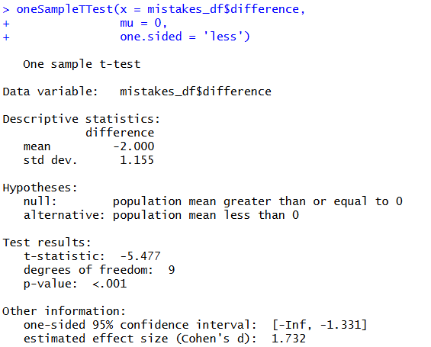

Part V (20 pts). Conducting an independent samples t-test and writing up results
For this part, you will use again the ECLS-K dataset.You are investigating the following research question:
Do students who are first-time kindergartners have a different average reading score than those who are not first-time kindergartners in the fall semester of kindergarten?
The variables of interest are:
- X1FIRKDG — whether the student is a first-time kindergartner (1: Yes, 2: No)
- X1RSCALK5 — the reading score in the fall semester of kindergarten
Assuming that the ECLS-K sample is representative of the population of U.S. kindergarten students, test whether the data support your hypothesis using a significance level of 0.05.

Data preparation:
      - Import the ecls-k-sub.csv dataset into R.
      - Recode missing values in X1RSCALK5
      - According to the codebook, the variable X1FIRKDG is a binary variable representing whether or not a kid is a first-time kindergartner (1: Yes, 2: No), and the values of -9 represent missing data. Recode these missing values to NA for accurate analysis.
      - Convert the X1FIRKDG variable into a factor using the as.factor() function.
- Write the null and alternative hypotheses in symbolic form.
$$H_{o}:μ_{1}=μ_{2}$$
$$H_{A}:μ_{1}≠μ_{2}$$
where $μ_{1}=$ average reading score for students who are first-time kindergartners, and $μ_{2}=$ average reading score for students who are not first-time kindergarteners

$$H_{o}:μ_{D}=0$$

- Run a two-sided independent samples t-test to compare the average reading scores of students who are first-time kindergartners and those who are not. Paste a screenshot of your R output below.

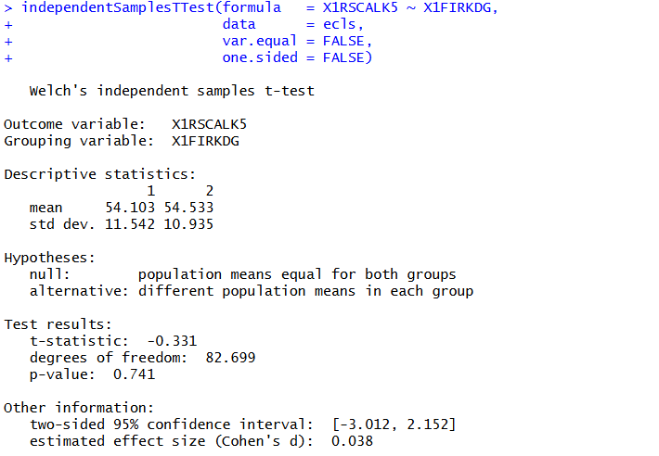
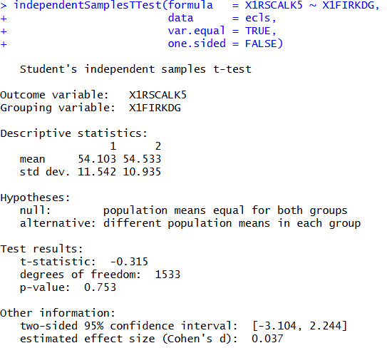

- Provide a brief APA-style summary of your findings.

No Equal Variance Assumption
A Welch’s independent samples t-test was conducted to compare reading scores for first-time and non–first-time kindergarteners. First-time kindergarteners (n = 1460) had a mean reading score of 54.10 (SD = 11.54), while non–first-time kindergarteners (n = 75) had a mean score of 54.53 (SD = 10.94). The results indicated that the difference between the groups was not statistically significant, t(82.70) = –0.33, p = .74, Cohen’s d = 0.04. This suggests that reading scores did not differ meaningfully between first-time and non–first-time kindergarteners.

Equal Variance Assumption
An independent samples t-test was conducted to compare reading scores for first-time and non–first-time kindergarteners. First-time kindergarteners (n = 1460) had a mean reading score of 54.10 (SD = 11.54), while non–first-time kindergarteners (n = 75) had a mean score of 54.53 (SD = 10.94). The results indicated that the difference between the groups was not statistically significant, t(1533) = –0.32, p = .75, Cohen’s d = 0.04. This suggests that reading scores did not differ meaningfully between first-time and non–first-time kindergarteners.

Part VI (20 pts). Conducting a dependent samples t-test and writing up results
Suppose you hypothesize that kindergarten students increase their attentional focus during the school year. The ECLS-K dataset includes two variables that measure attentional focus at two time points during kindergarten:
- X1ATTNFS – Attentional focus in the fall of kindergarten
- X2ATTNFS – Attentional focus in the spring of kindergarten
Each score ranges from 1 to 7 and represents the mean teacher rating across several survey items.
Higher scores on the Attentional Focus scale indicate that the child more consistently displays behaviors demonstrating the ability to focus attention on relevant environmental cues.
Assuming that the ECLS-K sample is representative of the population of U.S. kindergarten students, test whether the data support the hypothesis that students’ attentional focus increases during the kindergarten school year. Use a significance level of α = 0.05.
Data preparation:
            - Import the ecls-k-sub.csv dataset into R.
            - According to the codebook, the values of -9 and -1 represent missing values for both variables X1ATTNFS and X2ATTNFS. Recode these missing values to NA for both variables.

- Write the null and alternative hypotheses in symbolic form.
$$H_{o}:μ_{1}=μ_{2}$$
$$H_{A}:μ_{2}>μ_{1}$$
where $μ_{1}=$ average focus score for students in the fall, and $μ_{2}=$ average focus score for students in the spring
Alternatively,
$$H_{o}:μ_{D}=0$$
$$H_{A}:μ_{D}>0$$
Where μ_{D} is defined as μ₂ – μ_{1.}

- Run a dependent samples t-test (also known as a paired-samples t-test) comparing the mean attentional focus ratings in the fall and spring of kindergarten. Paste a screenshot of your R output below.
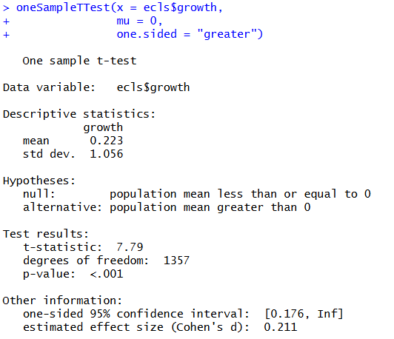
- Provide a brief APA-style summary of your findings.
A dependent samples t-test was conducted to examine whether attentional focus changed from fall to spring of kindergarten. The average rating for attentional focus in the fall of kindergarten was 4.70 with a standard deviation of 1.33, and the average for spring was 4.93 with a standard deviation of 1.32. Change scores were calculated by subtracting fall ratings from spring ratings, such that positive values indicated an increase in attentional focus. On average, students showed a small increase in attentional focus over the school year (M = 0.22, SD = 1.06). The results indicated that this increase was statistically significant, t(1357) = 7.79, p < .01, Cohen’s d = 0.21, suggesting that students’ attentional focus increased slightly but reliably from fall to spring.

